RDBMS Development

David Agaybi

991491884

10/02/2018

Professor Sheetal Thakar

1. SELECT \* FROM s2.baseoption;

SELECT \* FROM s2.car;

SELECT \* FROM s2.customer;

SELECT \* FROM s2.employee;

SELECT \* FROM s2.invoption;

SELECT \* FROM s2.options;

SELECT \* FROM s2.prospect;

SELECT \* FROM s2.saleinv;

SELECT \* FROM s2.servinv;

SELECT \* FROM s2.servwork;

1. 99.

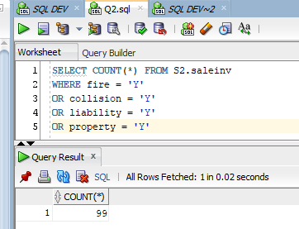



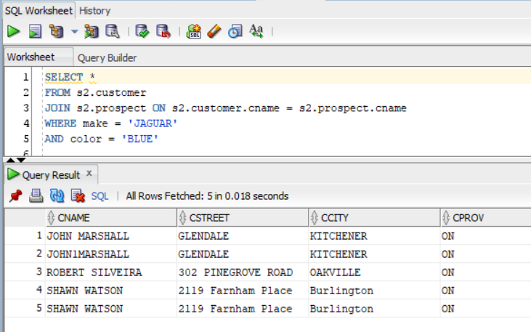

4.

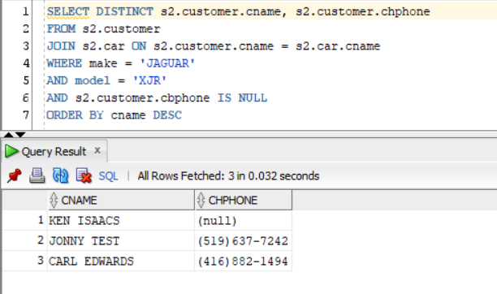

5.

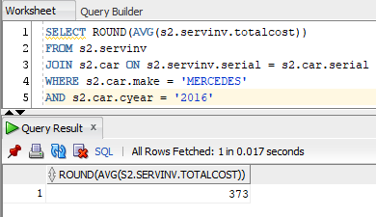

6.

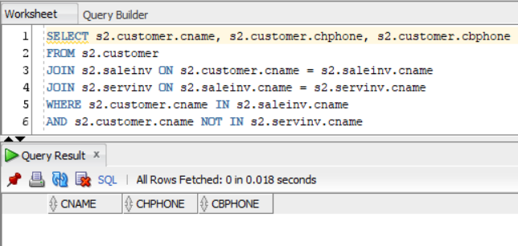

7.

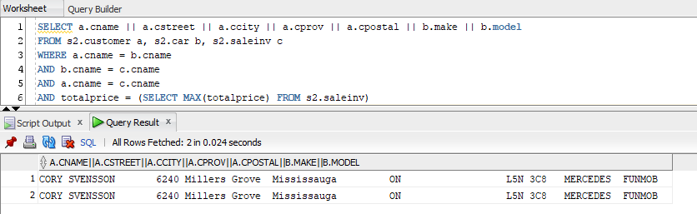

8.

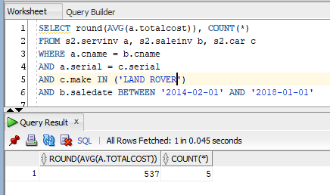

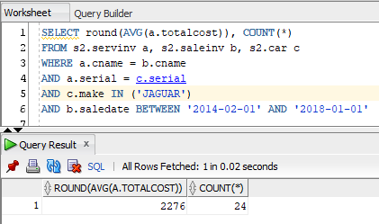

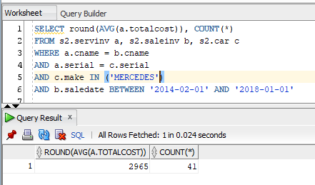

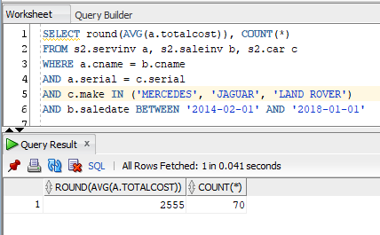

9.

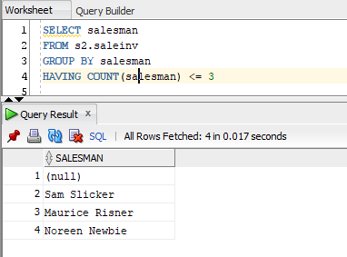

10.

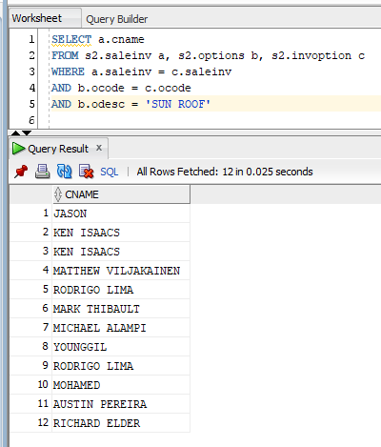

11.

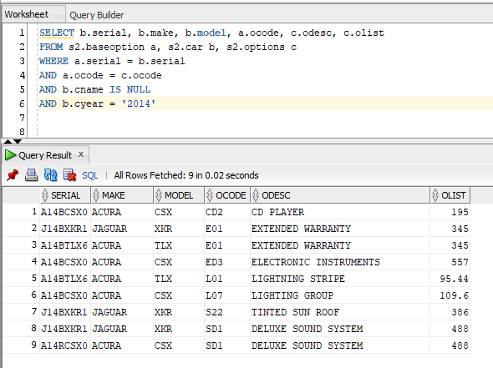

12.

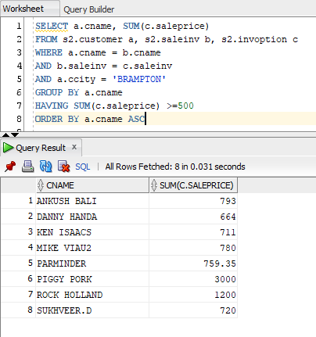

13.

